Jonathan Disla

Discussion 1.1

Web 420

Prof. Krasso

State is mentioned pretty early in chapter one of the book in the session section. According to the author, HTTP sessions last for one request. He adds, "the client and the server ... keep different kind of state" [Richardson]. The state emcompasses a user's session in an application. That is, if the user takes any action from within the application, the state is subject to changes. According to Nikovay Stoitsev who is a software engineer, "In any given point in time, there is a different information stored in the memory of your web application that you can access via your variables, classes, data structures, etc. All the stored information, at a given instant in time, is called the application state." The state is more temporary rather than persistant, meaning that records may not be saved after the user logs out or closes the application. In order for information to persist, we use resource state.

Resource state is the state of each individual resource being stored on the server. That may be files, images, database or database records to name a few. According to daylight, "Resource state changes as resources are added, modified, or deleted. One of the great advancements of the past twenty years in web development has been the adoption of the REST Architecture which is a stateless way of working with web resources. Each request in REST explicitly communicates its intended action on the resource and passes with it the information necessary for achieving that action" [Quisenberry]. The main difference here is that resources state maintains the data while application state is there while there is an ongoing session.

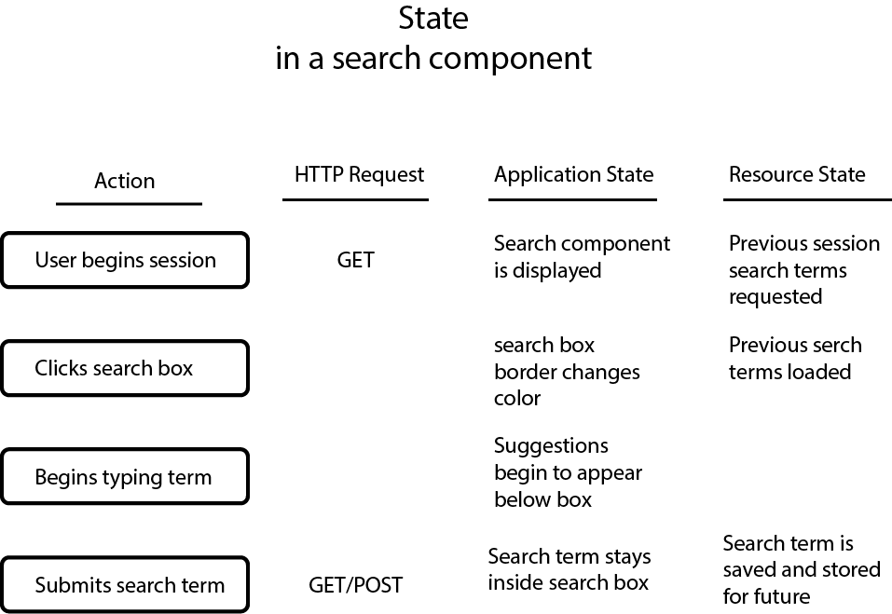

Reference List

Richardson Leonard. "Restful Web APIs." O'Riley 22 May 2015.

Quisenberry David. "What is State and Why Does it Matter?" Daylight, 14 March 2018.

<https://thedaylightstudio.com/blog/2018/03/14/what-is-state-in-web-application-> [development](https://thedaylightstudio.com/blog/2018/03/14/what-is-state-in-web-application-development)

Stoistsev Nikolay. "What's "state" in a web application?" Quora, 17 November 2015.

<https://www.quora.com/profile/Nikolay-Stoitsev>